Bangladesh University of Engineering & Technology, Dhaka.

Department of Computer Science and Engineering.



HOSPITAL MANAGEMENT SYSTEM

Submitted to:

Sajjadur Rahman
Lecturer, Dept. of CSE

Johra Muhammad Moosa
Lecturer, Dept. of CSE

Group No: 5
Group Members:
Mohammad Mojahidul Islam (1005011)
Shawrup Kumer Suter (1005016)
Shazibul Islam Shamim (1005019)
Md. Raiyan Ferdous (1005021)
Mahmudur Rahman (1005024)

Subsystems:
- Registration System
- Patient Management
- Employee Management
- Diagnostic center Management
- Billing System
- Scheduling System

Data Flow Diagram of each Subsystem:
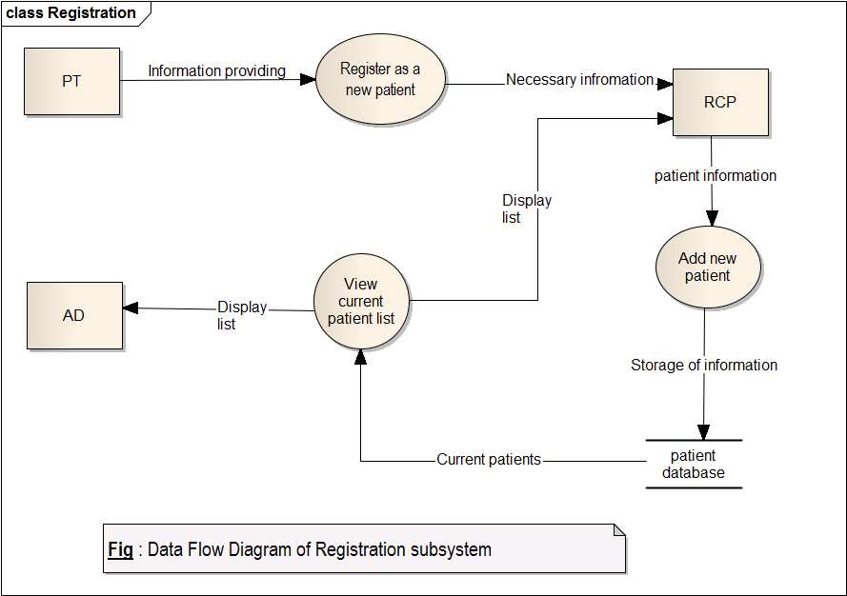
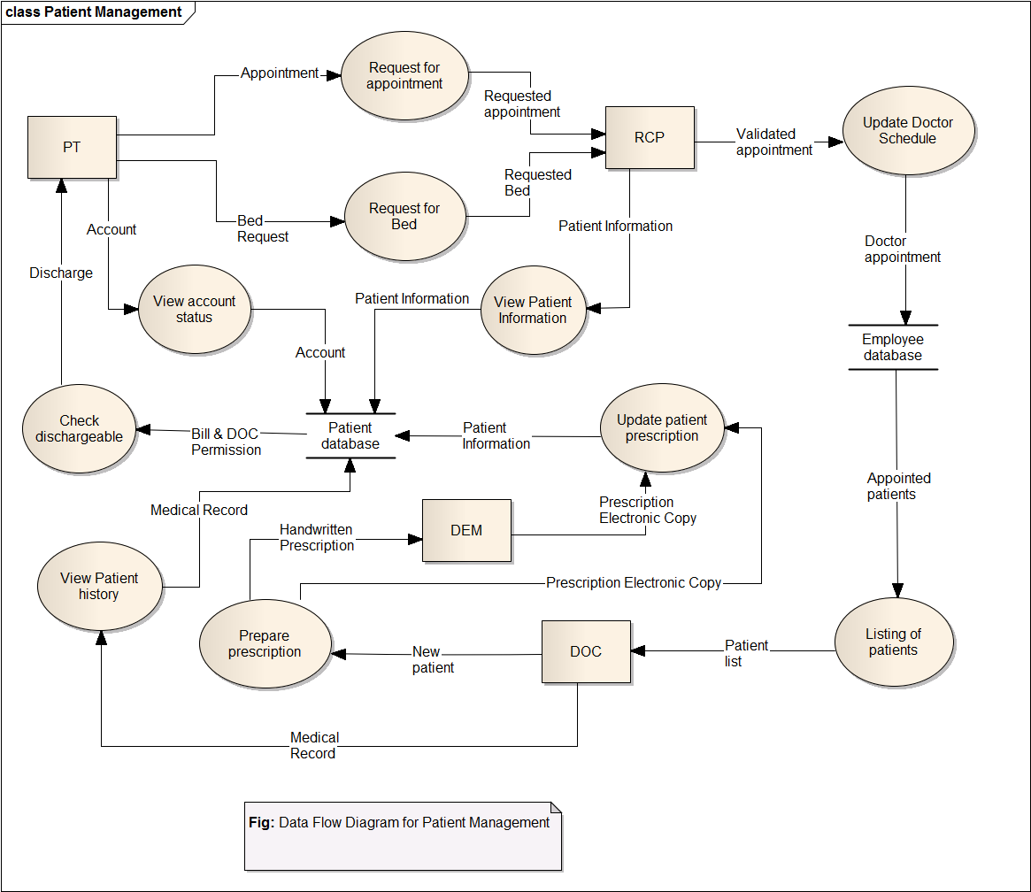
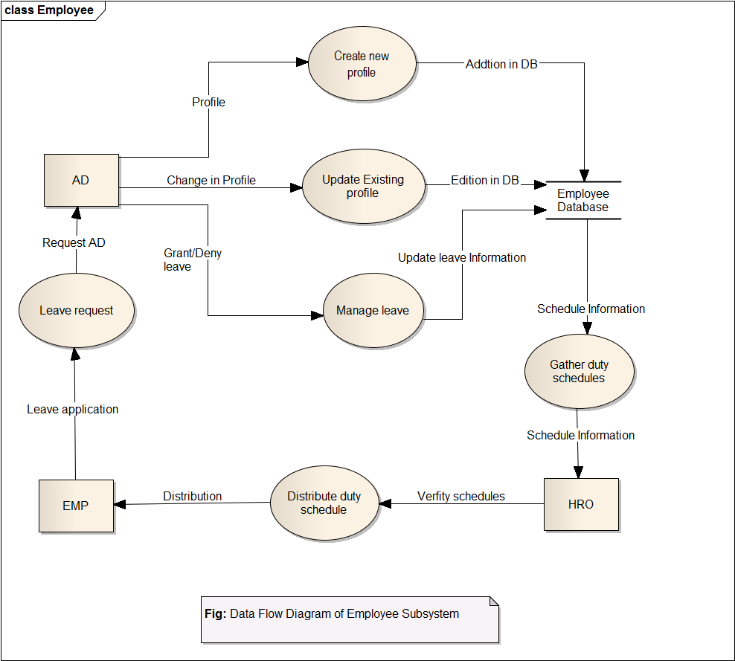
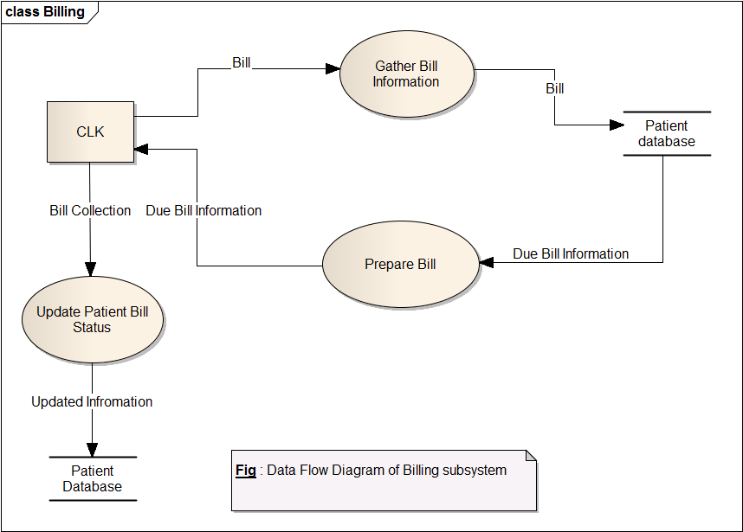
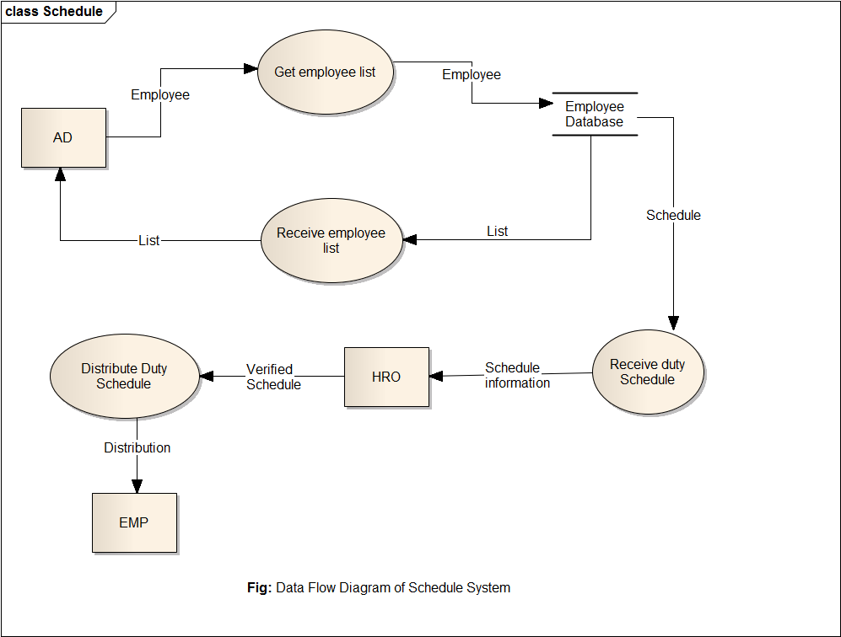

Fish bone Diagram of each Subsystem:

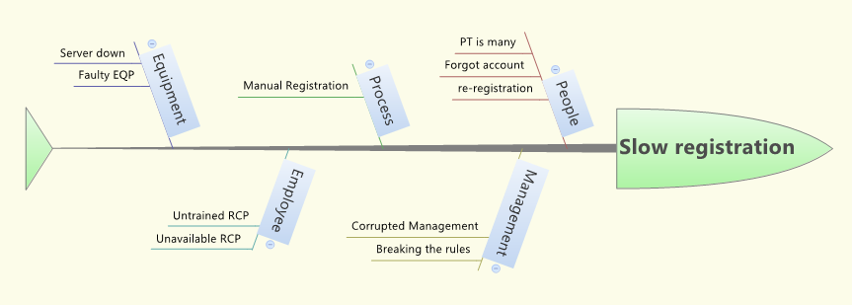
Fig: Fish Bone diagram of Registration System
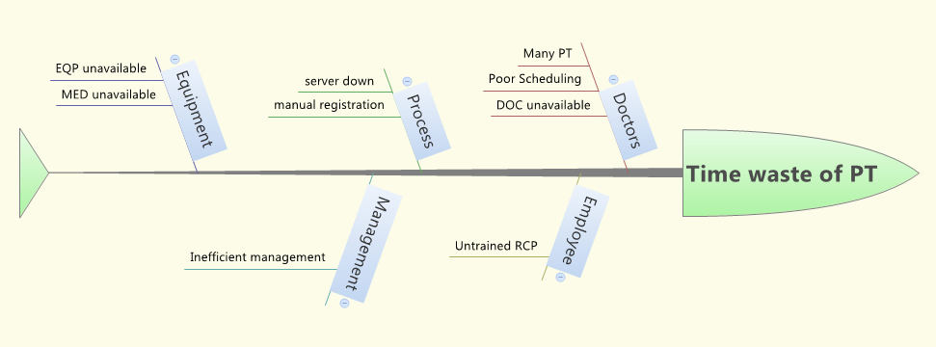
Fig: Fish Bone diagram of Patient Management System
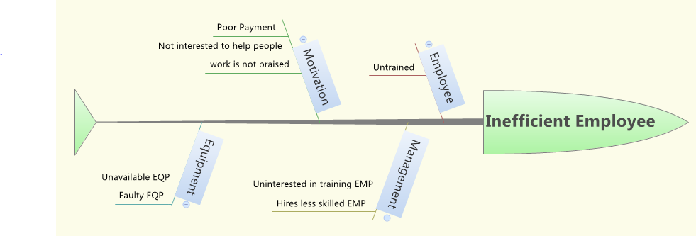
Fig: Fish Bone diagram of Employee System
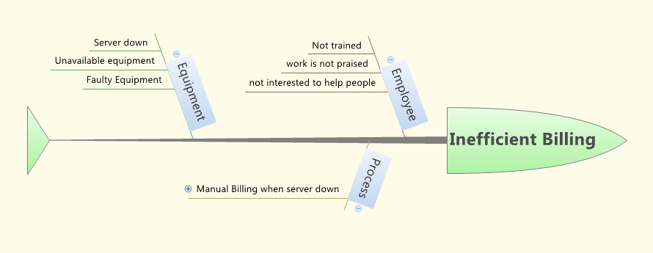
Fig: Fish Bone diagram of Billing System

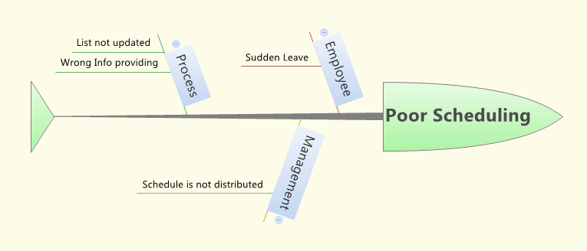

Fig: Fish Bone diagram of Schedule System

Operational Feasibility:
Points are to be considered when studying human organizational aspects of hospital management system:
- What changes will be brought with the system?
- What organization structures are distributed?
- What new skills will be required?
- Do the existing staff members have these skills?
- If they don’t have, can they be trained in due time?
The system is operationally feasible as it very easy for the End users to operate it. It
only needs basic information about Windows platform and how to use files on this system.Some new skills and usage of our software system will be introduced.Obviously staff members don’t have these skills.That can be well trained within olny approximate 2-5 days.If any technical problems occurred they will notify technical person or software analysts.

Technical Feasibility:
This evaluation determines whether the technology needed for the proposed system is available or not.
- Can project be implemented with the current existing software technology & available?
- Can the system be upgraded if developed?
- If new technology is needed then what can be developed?
- Will specified equipment and software satisfy user requirements?

An important issue for the development of a project is the selection of suitable front-end
and back-end. When we decided to develop the project we went through an extensive
study to determine the most suitable platform that suits the needs of the organization as
well as helps in development of the project.
The aspects of our study included the following factors.

Front-end selection:
1. It must have a graphical user interface that assists employees that are not from IT
background.
2. Scalability and extensibility.
3. Flexibility.
4. Robustness.
5. According to the organization requirement and the culture.
6. Must provide excellent reporting features with good printing support.
7. Easy to debug and maintain.

Back-end Selection:
1. Multiple user support.
2. Efficient data handling.
3. Provide inherent features for security.
4. Efficient data retrieval and maintenance.
5. Stored procedures.
6. Popularity.
7. Operating System compatible.
8. Easy to install.
9. Various drivers must be available.
10. Easy to implant with the Front-end.

According to above stated features we selected Oracle Database as the backend.
The technical feasibility is frequently the most difficult area encountered at this stage. It
is essential that the process of analysis and definition be conducted in parallel with an
assessment to technical feasibility. It centers on the existing computer system
(hardware, software etc.) and to what extent it can support the proposed system.

Economic Feasibility:
Economic justification is generally the “Bottom Line” consideration for most system
Economic justification includes a broad range of concerns that includes cost benefit
analysis. In this we weight the cost and the benefits associated with the candidate
system and if it suits the basic purpose of the organization i.e. profit making, the pro
is making to the analysis and design phase.

- Is the project possible, given resource constraints?
- Are the benefits that will accrue from the new system worth
the costs?
- What are the savings that will result from the system,
including tangible and intangible ones?
- What are the development and operational costs?
The financial and the economic questions during the preliminary investigation are verified to estimate the following:

- Software Development Cost:
Number | Type of Employee | Estimated work time & pay rate | Cost
2 | System Architect & Analysts | 50hours(400tk/hr) | 40000tk
2 | GUI Designer and Programmer | 100hours(350tk/hr) | 70000tk
1 | Database Specialist &System Librarian | 50hours(300tk/hr) | 15000tk

- Expenses for training:
Number | Type of Trainee | Duration | Package | Cost
20 | Doctor | 3 hours | 2000tk | 40000
10 | Clerk | 4 hours | 1500tk | 15000
15 | Receiptionist | 5 hours | 2000tk | 30000
3 | Data Entry Manager | 8 hours | 4000tk | 12000

- New Hardware and Software:
Number | Type | Per unit cost | Cost
1 | Development Server | 5000tk | 5000tk
1 | Server Software & hosting | 10000tk | 10000tk
1 | DBMS server | 4000tk | 4000tk
2 | DBMS client hosting | 6000tk | 12000tk
35 | Desktop Computer | 25000tk | 8,75,000tk
3 | Printer | 15000tk | 45000tk
 | Wires and Other equipments | 70000tk | 70000tk
- So total Development Cost= 12,43,000tk
- Annual Cost:
Number | Designation | Cost
2 | System Librarian | 2,40,000tk
1 | Database programmer | 1,80,000tk
1 | IT specialist(part time) | 1,00,000tk
1 | Maintenance Agreement server | 5000tk
1 | Maintenance Agreement DBMS server | 10000tk

- Annual Maintenance cost=5, 35,000tk
- Fixed Costs:
1. Salary of IT management team
2. DBMS Server maintenance.
3. Web Server Hosting charge.
- Variable Costs:
1. Maintenance of Computers and repairing them.
2. Maintenance of other Equipments like wires, Printers etc.

So we can say that economic feasibility is good for this project.

Tangible Benefits:
- Registration system is online so it saves 5 minutes compared to previous system. On average there are 100 new patient admitted to the hospital in a day. So it saves almost 8 hours of extra work as well as duty of an extra receptionist which saves around 1,50,000tk per year.
- Medical Prescription, Medical reports and all medical history are saved in server. On average the hospital prints out 200page billing memo for official records alongside with patients copy. So it saves 200*365*1.50= tk per year.

Intangible Benefits:
- Hospital can provide better service to its patients. Wastage of time of patients is reduced. So we have patient’s good wishes.
- The job of receptionist and clerk has been made easier and more accurate.
- If the patient loses his prescription he can easily download them. So the system makes the life of patients easier.

